ET Open Mic at March 21, 2024 Large Gathering in G-1 and Zoom

* [My understanding is that] the Common Table meets five months of the year on Saturdays. Could [our current] working groups and other groups that we already belong to be the [engagement] groups that meets on the alternate months from Common Table assemblies. That would make people’s general calendar a little more simplified and it would still allow for new community members to come in. (RQ)

* (Joan Mitchell) These are things we would have to hold in process. We probably can’t figure them all out tonight.

* There is a lot of information here, but what I feel really uncomfortable about is that there is no quantitative information. Did one person say this? Did 52 people say this? Without that, I don’t see how this can be representative. (FM)

* Would the meetings for the small [engagement] groups necessarily have to be on a Saturday? (SO)

*(Joan Mitchell) No

* OK. On the alternate months, the small groups would meet at some point during those months. So the Common Table would meet five Saturdays a year and in the alternating months, there would be meetings for the small groups, but those wouldn’t have to meet on a Saturday. (SO)

* (JM) Next, we are going to go through here [the Proposal] and any suggestions you want to surface; suggestions, questions.

* What about a dialogue with the Community Assembly [Planning Committee]
[current CAPC members: Fran, Rita, Meg G., Jill U. leadership laison] about doing this work through the Community Assembly? I think we all recall that the CA was established to do this. Could we revitalize that original mission and engage it with each other? So maybe the combination of learning how many people like this idea [Common Table Proposal] along with engaging amongst ourselves about how to use the Community Assembly. (SH)

* I just wanted to share that in our small group there was a lot of confusion and puzzlement about this Proposal and its relationship to Community Leadership, the charge of creating some kind of Community Leadership Group. I’m concerned when I hear things like suspending Commissions. The Commissions do a lot of work that’s not happening at Community Assemblies. It’s happening at monthly meetings and at other times all throughout the year. If I’m asked to continue to be part of a Commission, but there is no Community Assembly that the Commissions are getting their authority from, there is no Leadership Team responding, I just not sure what the role of a Relationship & Association Commission might be as just a small group. So I’m a little confused. I like the idea of the Common Table and maybe Community Assemblies could become more like this, but I’m confused by the notion of disbanding or suspending the Commissions, especially. (EC on zoom)

* I have concerns about disbanding the Community Assemblies. It seems that it is working. I really like the idea of coming together more often. It seems like I am hearing that from everybody every time we come together. We all want to know each other more. But if we do come together more often, somebody[ies] have to plan all those gatherings, and I’m thinking the CBLG might be the ones doing that, but I haven’t heard anybody talking about a CBLG yet. (LL on zoom)

* In our discusssion at our table, we didn’t know where the decision was going off of the shared leadership group, looking at that, deciding on how that would be….to then coming into a whole new one-year experiment with a Common Table. Now maybe there is a connection that some of us just aren’t getting because we haven’t gotten the information. How did you as a group make that leap and the rest of us haven’t been able to follow with that. The second thing is, I think if you are going to put together an experiment that it would be very helpful that you lay out the purpose and the goals so that at the end of the experiment you can decide if it worked or it didn’t work. (AD)

* I want to build on what Eric and Lilly said. I want to refer to the third section of the Proposal you sent us, Network of Engagement Small Groups, the last dot: Each group needs a convener and a scribe to communicate with the Common Table, community-based leaders. I thought the development of a Community Based Leadership Group was the charge of the Engagement Team that has been engaging us in conversation over the past several months. So I went back to the description of what the charge was to the engagement group. “Engage broader Community to create a description of the purpose, scope of work and structure of the community-based leadership group.” [see CSJ Forum for ET job description].
It seems to me, that presenting a proposal like this would be something that would grow out of the CBLG that the engagement team has been charged to develop. I think the CBLG becomes a new planning group with more authority, more clear roles, etc. That’s what I thought ET would be bringing to us, rather than a new design on how to come together. I want to say, along with three or four others who say, “I am confused.” (JW)

* This proposal is really a synthesis of all the conversations that have taken place. It is expressing what we hear from you at the tables over these past months. We want you to respond to us. Is this a direction that you want to go? Before you have the community-based leaders assigned for planning, let’s get some sense of, “Is this the direction? Is this the vision? Is this how we imagined community being together? Respond to that on your feedback sheets. Please. We want to push this and raise it to a higher level. Put the questions that this raises on your feedback sheets so that we can go forward. (MLM)

* I agree with Mary Louise, but this is a step-by-step proposal. It’s not opening it up to, “what do we see? How does it work? Do we want to do this?” That’s not what this is doing. This is saying, ‘here’s a proposal, let’s do it. And here’s how we can do it. So there’s a difference between let’s talk about this vs giving us steps on how it’s going to work.
Please don’t forget that the Sisters have Chapter this year so we have many meetings that we are going to have to have to prepare for Chapter so that’s adding more meetings (KR)

* The question, “How do we get there?” is really about the movement. One of the issues that came up is that sisters go here [Sister Assemblies]; consociates go there [Consociate Assemblies]. How do we talk about what we do together when we are not together? That was one of the issues that came up in conversations. The second issue is that there is 176 Consociates. I see 80% of same Consociates at events.
It isn’t an either/or; it’s how do we take what works and how do we modify it so that we are coming together as a Common Table of everyone. How is it that we invite more people in. There are about another 100 folks [Consociates?] out there that I have never met. And what is it about the format that we do that may or may not invite them in? [We are] asking how do we come together so we aren’t meeting in separate rooms [Sister Assembly room and Consociate Assembly room]. How do we get more people at the table and how do we change what we’ve done? It’s never easy to change: Mayday Coffee Shop’s tip jar, “If you fear change, leave it here.” (HF)

* I think we have two ways of operating: (1.) we plan something out extensively and then we try to make it work or (2.) we take a leap and experiment with something and try it and see where it brings us. I think this [One Year Experiment proposal] is a ‘where does this bring us’ one. How can it harm, ‘getting to know each other better’ and seeing, ‘where does that bring us’ in terms of Community Based Leadership? (TS)

* This is what we talked about trying to do, to connect with each other. It’s not about throwing away the Community Assembly. It’s really about making the Community Assembly serve us, rather than us serving a structure. (KO)

* (JM) Ok. It’s really important to get feedback on these parts. I want to make one clarifying remark: in the third part [of the Proposal- see below]: So it is not disassembling the Justice Commission. Joan Mitchell
Network of Engagement Small Groups
- Gather on alternating months in small groups for the purpose of building relationships with one another, hearing from existing ministries, identifying and responding to new needs we encounter.
- These groups can include those already formed such as Justice working groups, Pathfinders, DEI[&B] and Membership, friendship groups but importantly also new mixed groups that form as a way to participate [in] CSJ evolving mission.
[see CSJ Forum for entire March 21 Proposal]

* My experience on [Relationship & Association Commission] is that we had five or six committees that were working on specific things. Those committees could evolve into interest groups. That might draw a greater collection of people to come to an interest group on a particular thing than to come to a Commission meeting once a month. (PS)

* I want to state a couple of concerns I have about subsidiarity. It would be important, I think, for each of the groups that are mentioned here, DEI and Membership & Association and Justice Commission, to be able, as their assembled groups, to think about how they would fit into this. It feels a little awkward to me that we’re all thinking about how they could fit into this without them and their groups thinking about it themselves. And too with the Sisters Assembly, to think about how that work is done if they’re not meeting on Saturdays. Subsidiarity in the groups themselves thinking about this is important. (JU)

* One of the things we are hearing is that, although it has a new name, it sounds a lot like the Community Assembly. The CA is not growing with new people because Saturdays don’t work. The CA planning committee already has sisters, consociates, friends of St. Joseph and has had SJW’s. The times didn’t fit for the SJW’s. It doesn’t seem like we have an appropriate experiment if we don’t change the time. (CS)

* I want to sincerely thank everyone who stepped forward to be involved in this. Could we have a show of hands of everyone who has been involved in this. (response was: “All of us”). I just want to say thank you to anyone who has stepped forward to work on this. (BK)

* (JM) I think one of the things we were trying to do in this meeting was to push things a little farther. You could continue to call this the Community Assembly, for that matter. It [the Proposal] would be trying to bring in things more from the groups rather than have the Community Assembly Planning Committee do it. That is already happened to some degree. Joan Mitchell

* (EC on zoom) In our small group we expressed that it is often in the doing of the work that we get to know each other and that without some common purpose bringing us together, it’s hard to get to know each other. Yet, there was also a tension with the fact that sometimes there is a little too much reliance on that work, expecially in the era of pandemic and zoom meetings. We’ve lost that time whether at the beginning of meetings or while we eat together, where you get to know each other personally and get to know where you come from, how you grew up, who your family is and appreciate each other in that way. So it felt like this community table idea was to get together at the Common Table, some of that getting to know each other in simpler ways than just doing work together. But the concern is that even that, even pulling people together in that way, takes planning. The question was, where is that planning coming from? It [the Proposal] seems to be missing that foundation of who will plan even those Common Table activities? So that was a concern. (EC)

* (JM) Yes, that [the concern expressed] is not in this. Joan Mitchell

* How do we communicate with all these different groups so that people know about all of the different groups, people are invited to the different groups and that to build the community with all these different areas, which I think is a beautiful thing to do, how is that going to be effectively communicated so that people all have the same information and an openess and transparency about all of this. I think that is a very important part, to consider this, to be a successful pilot, that we really need to think about how things are communicated today because we are really siloed big time and very little of this is coming through and so how do we make that really open, what’s going on, what people are planning, but then also, everyone is being invited. Thank you. (AD)

* I feel that the important thing that we already have in place, is the infrastructure for ministries and commissions and we have very important key work areas. What I feel is missing is the connections among the ‘wider we’ and that’s what this ultimately has to be about. Sisters of St. Joseph community will always need the infrastructure and the whole orientation toward justice and project areas. All the bigger decisions like that, do we move into this area or not. That’s a different kind of question, but what needs to happen is that we become a more cohesive community around the issues. I hear a lot of people expressing that in my group and I feel it also that the infrastructure needs to be modified in some way, but there are things that still matter greatly in the existing infrastructure. So, how can we protect and preserve the elements needed and the authority relationships that still are required for various purposes within the Community (KG, Partner in Ministry).

* Is there a way to reach out and check in and touch base with people in the Community we are not seeing at the gatherings? Asking them if they are interested in connecting back. Asking them, what is your schedule? (AMc)

* There are a lot of things already happening like Jennifer Tacheny’s relationship with students about food justice and Mary Louise Menikem’s experience with Restorative Justice and Anne Hannahan’s group that meets on Mondays that we could hear about and from that people will work on things together. (MW)

* I’ve noticed in the groups that I’ve convened on zoom and the outreach I’ve done, that the web [communication of information ] that the Sisters have is very strong. For example, in the CSJ Drumming Circle, if we’ve got a change in schedule, it will pass efficiently along the sisters’ web of communication. I’ve also noticed, from doing a lot of calling people and trying to connect Consociates, that our [relational] web is very weak within the Consociates. It’s very weak.
I’ve spent time emailing, calling and then texting, “we need help and just answer, ‘yes or no’ and not getting an answer. It’s [the relational web] very weak among Consociates. One of the things that was said that I think is so true is that the Sisters cannot do this work for the Consociates. It is the Consociates’ work to do. When we are trying to think, “how can we reach out? How can we get people here?”…..It’s more than just leaving a voice message. We really need to, one-on-one to hear people’s stories. They are facinating stories within the Consociates. Forming real relationships; not just a phone call. That is our work to do. (RC)

* I’d like to thank everyone for their deep, thoughtful comments. This is important work. This is a movement of where we are going to go in the future and how we are going to be Community together and build that Community. MLM
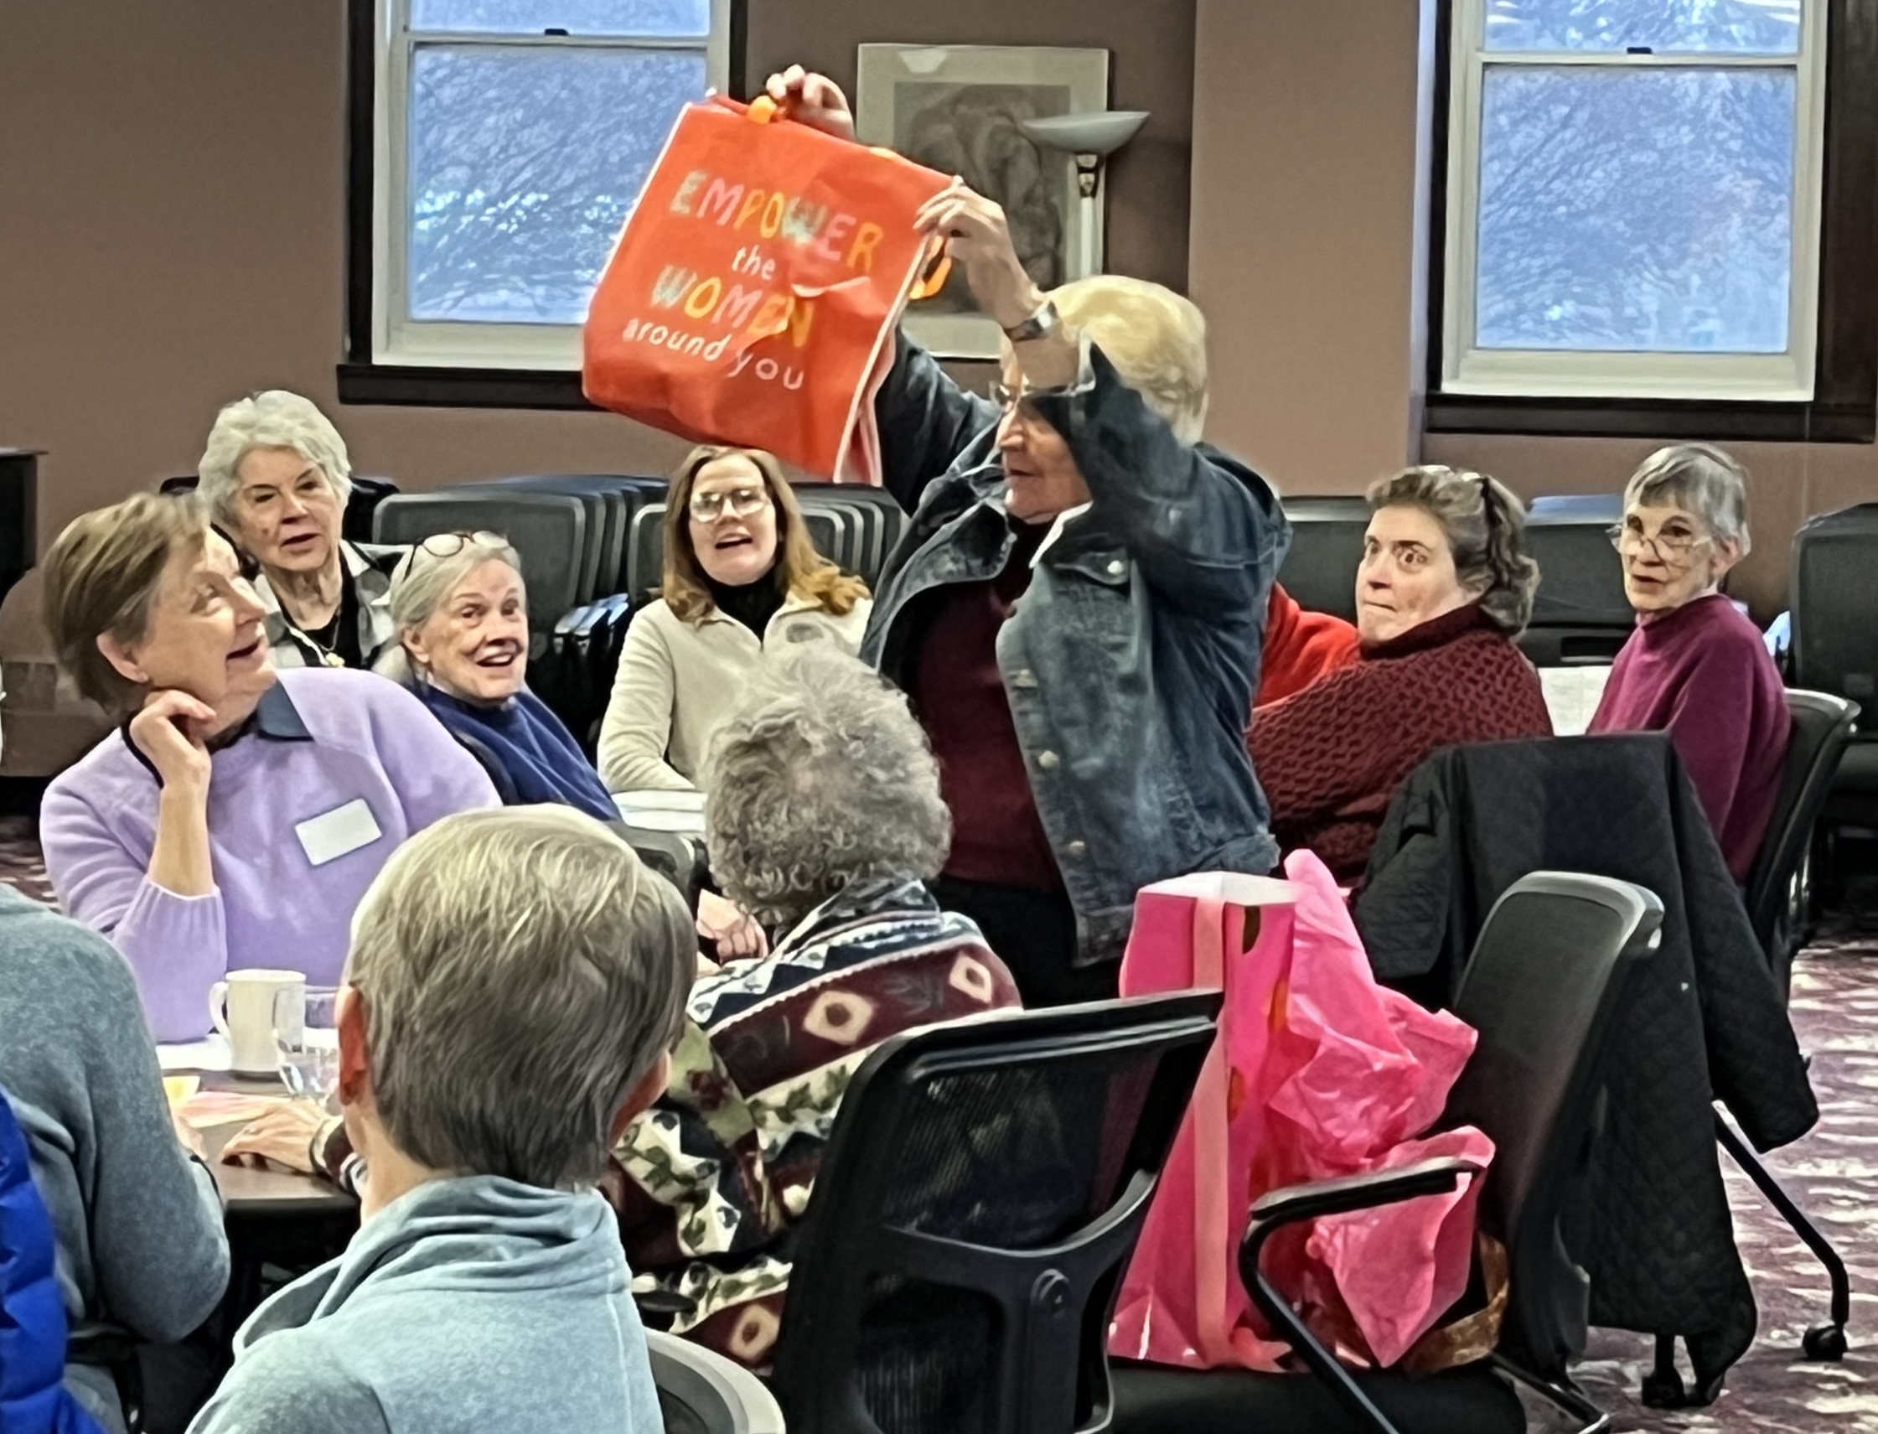
“I think we have two ways of operating: (1.) we plan something out extensively and then we try to make it work or (2.) we take a leap and experiment with something and try it and see where it brings us. I think this [One Year Experiment proposal] is a ‘where does this bring us’ one. How can it harm, ‘getting to know each other better’ and seeing, ‘where does that bring us’ in terms of Community-Based Leadership.?” (TS)

