CARAVAN (“moving always toward profound love…”) Discussion 1.4.24
The Caravan is a group of us who rode together to Peg’s prairie last summer. We picked us several lively additional “passengers” and zoomed on Jan 4th together. The Caravan includes: Rosemary Curran, Kay Egan, Karen Zeleznak, Kathie McLaughlin, Kate O’Connell, Susan Hames, Peg Schwendeman, Susan Oeffling

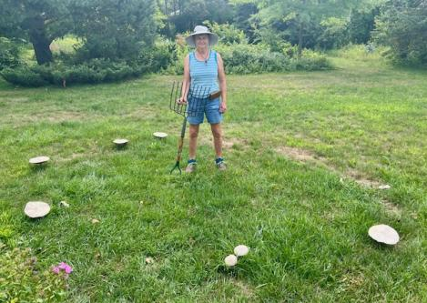
The CbLG could function as the hub (circle of mushrooms) of the wheel (mycelial networks without edges/distinction).

The new entity needs to:
*be countercultural (continue CSJ countercultural legacy)
*be nimble to adapt to the needs of the future and evolving stages.
*be a way of exploring who/how we are in the world through rituals which transform us. “Connecting our experiences out in the fray with the interior of our lives”
*be a center of compassion, how we overcome our interpersonal differences matters. Where does love take you in the hard interpersonal situations? Where does the charism show up?
*hold/weave us together with the mission. How do we stay connected? How do we express love in action?
*deepen our partnerships and connections with the people at the edges and the margins. Are we called to join with others, rather than try to get them to join with us? (Not recreating the wheel internally….go out to where organizations are working for social change).
*pay attention to the Acts of Chapter

Perhaps first we want to determine how we want to be (our ethos), then determine what we want to do; from there the form (structure of the CbLG Table) will emerge as we engage with one another in the Community and come to consensus.

Is our mission two fold: “How we be in the world and How we accompany (Pope Francis) those in need?

How we operate becomes the way. Pay attention to what haunts you. How do we hold/navigate the tensions (in relationships and between structures)?

What is our vision for Community Assemblies that hold us?....that hold us together?
Ritualizing our relationships, re-membering
What inspires you, what is life-giving? How do you give back? What would encourage you to be part of this future entity we want to create carry the mission and charism into the future?
Lifegiving relationships: inspiring, talk, pray, laugh together.
Finding ways to educate ourselves and step into our inner leadership (feminist theology), exploring together, telling our stories.

RESOURCES:

https://archive.org/details/feministcaseagai0000ferg/page/n3/mode/2up All 312 pages of Kathy E. Ferguson’s book, Feminist Case Against Bureaucracy are here.

Dr. Tande dissertation

